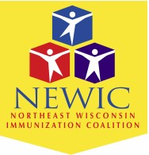
NEWIC Immunization Champion Award 2024

Nomination Form
The Northeast Wisconsin Immunization Coalition is proud to honor a person who demonstrates a strong commitment to increasing immunization levels through education, advocacy, and leadership.

How to nominate
Any NEWIC member or non-member may submit a nomination!
Send your completed form to: mail to:NEWIC.izchampion@gmail.com

Nominations close
March 8th, 2024
Nominee Details:
YOUR NAME & ADDRESS: | NOMINEE’S NAME & ADDRESS
YOUR EMAIL: | NOMINEE’S EMAIL:
YOUR PHONE NUMBER: | NOMINEE’S PHONE NUMBER:
Please describe why you feel your nominee is a Champion:

